­­­­­­­­­­­­­­Step 1

#Launch Ec2 Instance in aws console

Step 2

# Load. **pem** in puttygen then save with .ppk

Step 3

# Then putty copy paste public ip in Host name ec2-user@(**public ip**) ec2 launched and go to config then **ssh auth**>>> cred browse stored private key**(.ppk)** and then proceed

Sudo su –

Yum update

Yum list docker

Yum install docker

Docker version check

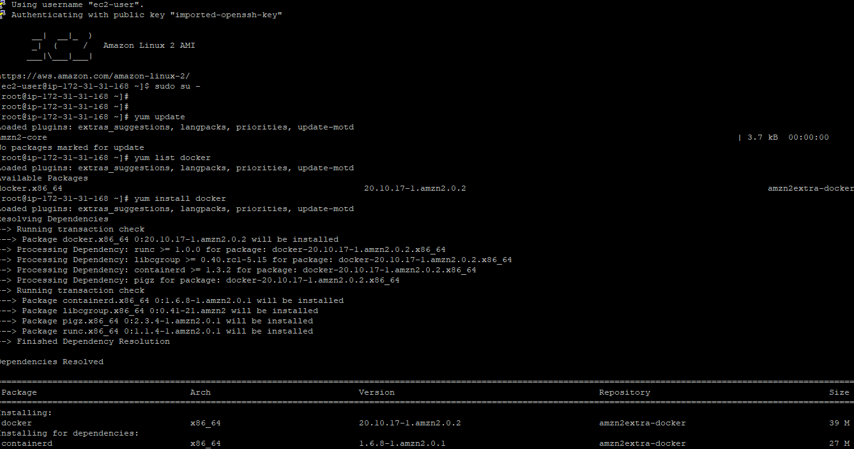

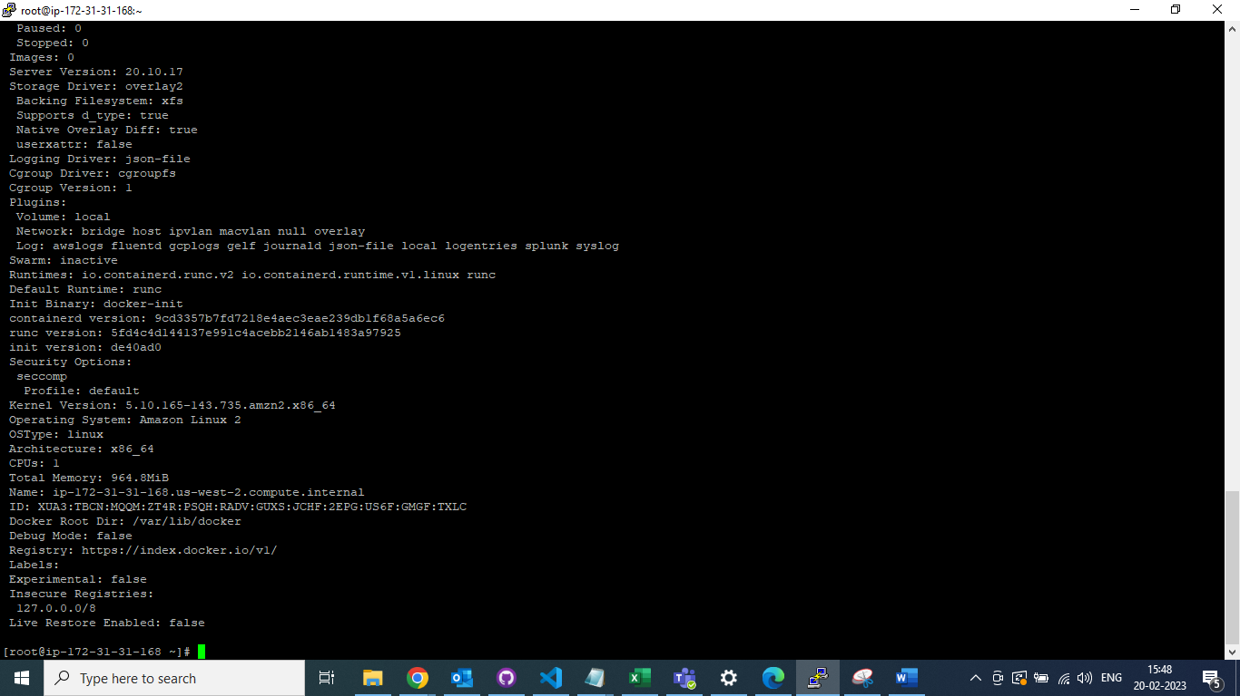

Docker version check



Sudo su –

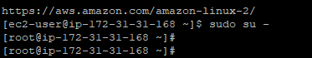

Yum update

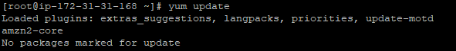

Yum list docker



Yum install docker

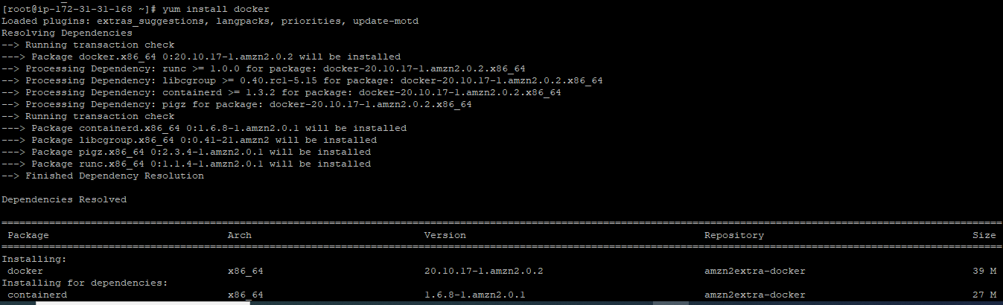

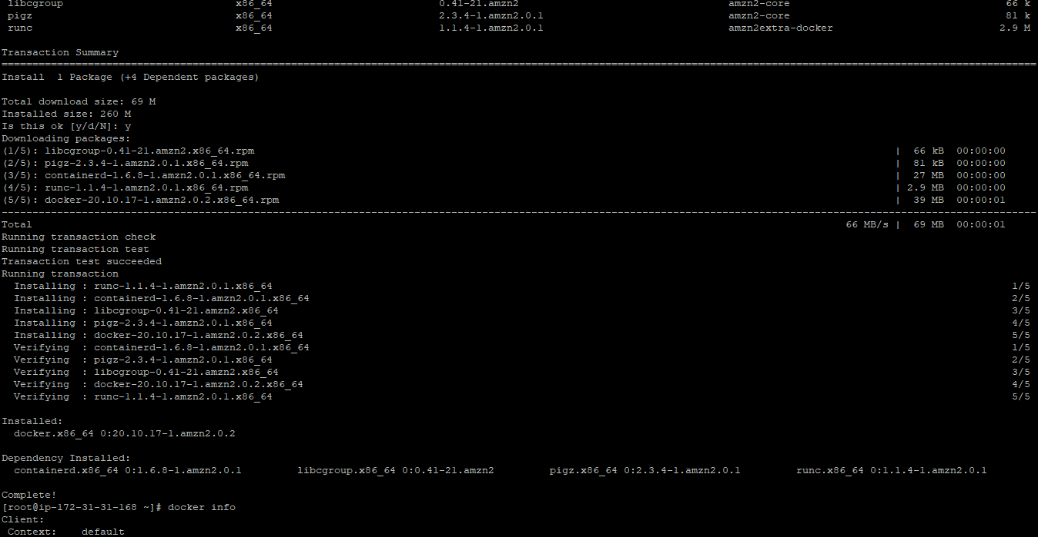

­­

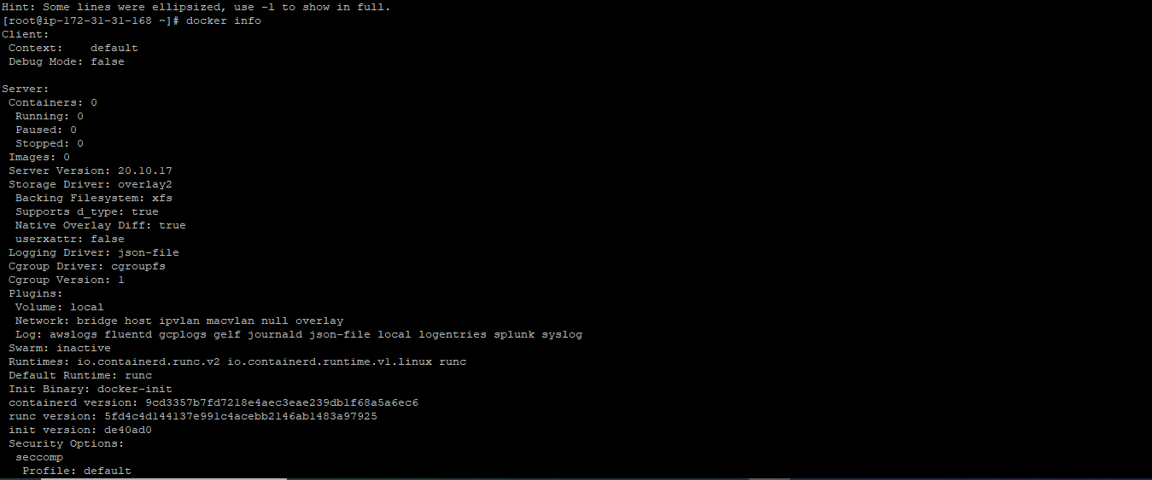

Components  
*************  
Hub  
Engine  
Images  
Containers  
volume  
Docker file

<https://docs.docker.com/engine/install/ubuntu/>

docker run hello-world  
docker ps  
docker ps -a

Commands  
*********  
docker --version  
docker info  
/var/lib/docker

docker pull nginx  
docker images --all  
docker container run -dt --name myubuntu ubuntu - Detached mode, run a container  
docker ps  
docker container exec -it <container.id> bash  
docker container stop <container.id>  
docker container rm <container.id or name>  
docker ps -aq    - shows the container ids  
docker container rm $(docker ps -aq)  
docker kill vs stop

docker images  
docker rmi <image.id>

Docker version

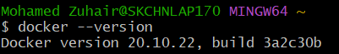

Docker info

